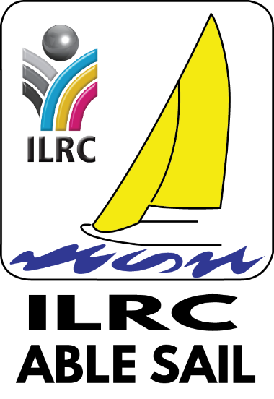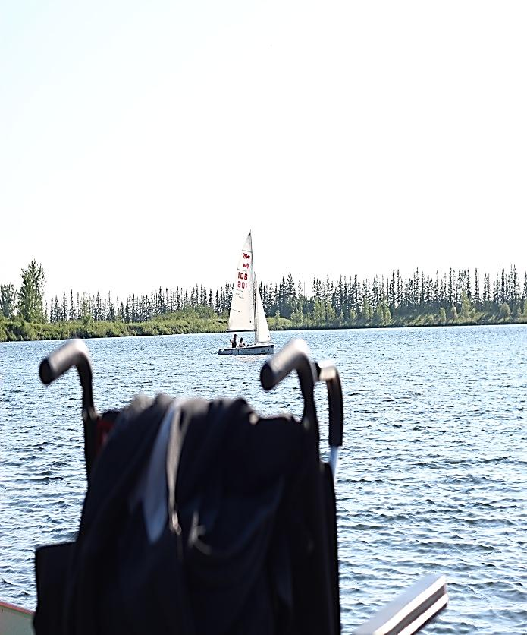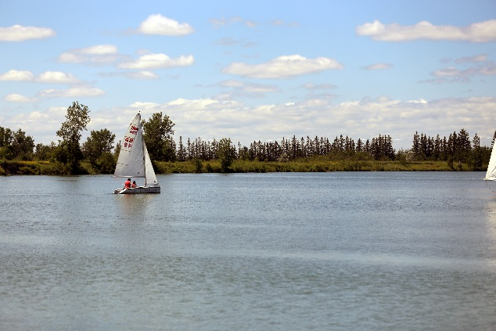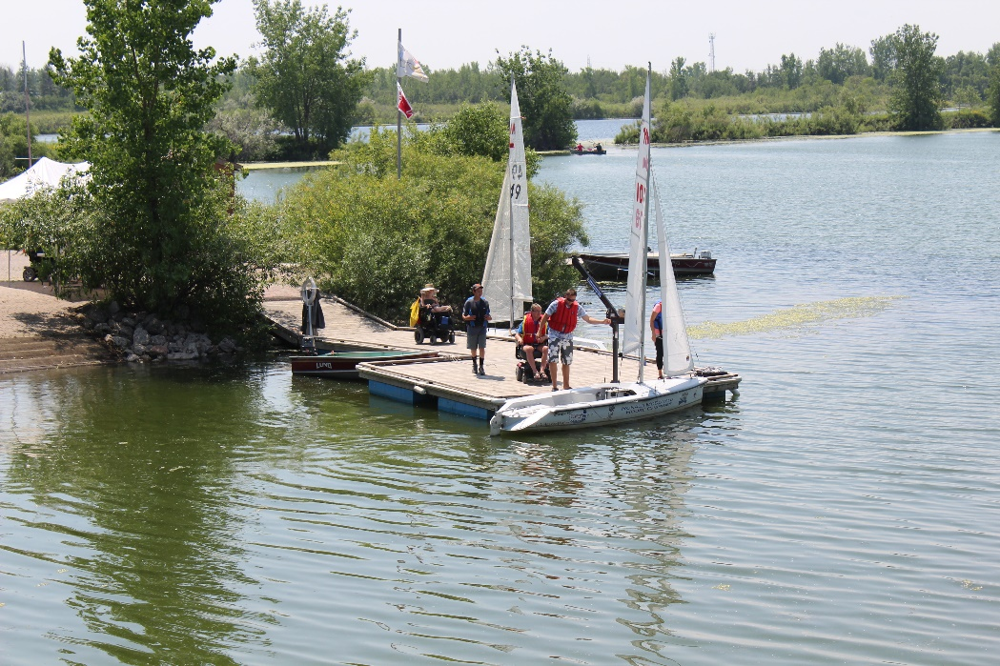 

**Independent Living Resource Centre Inc.**

100-167 Lombard Avenue, Winnipeg, MB R3B 0B3

[www.ilrc.mb.ca](http://www.ilrc.mb.ca)

1961 McCreary Rd.

Winnipeg MB R3P 2K9

The centre@ilrc.mb.ca

204-947-0194



Join Us!

The Freedom of Sailing is for everyone

Sailing in the City

About Our Boats

ILRC Able Sail sails a fleet of Martin 16 Sailboats. The Martin 16 is a breakthrough in small boat design. From its inception, the Martin 16 was designed to be accessible to all sailors regardless of experience.

Our Boats Feature:

* A weighted keel that makes the Martin 16’s stable, and virtually uncapsizable.
* Flotation Foam within the Hull of the boat allows the boat to continue afloat if punctured.
* A self-tacking jib frees the sailor from heavy line hauling
* A second seat provides room for a sailing instructor, or a qualified sailing companion

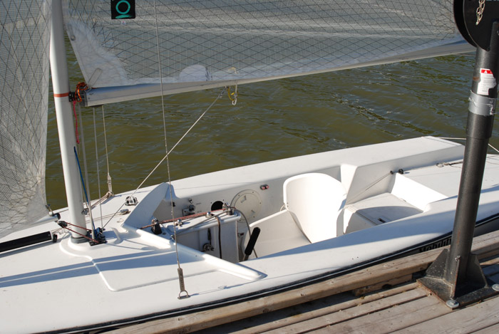

*- Disabled Sailing Association*

*of British Columbia*

“The Martin 16 is a breakthrough in small boat design”

Special Events

Open house

Each summer ILRC Able Sail offers an open house for all to experience the joy of sailing at no cost. Ask about our open house date.

Volunteers

Working with sailors with disabilities is a great way to get outside and learn more about sailing while supporting the disability community. Call us now and get involved!

Our goals

* To provide a unique and enjoyable experience for members and casual sailors that include opportunities for social, recreational and competitive activities.
* To build confidence, self-esteem, and create enhanced independence for people with disabilities.
* To facilitate integration of sailors with disabilities into the full sailing experience.

Independent Sailing

An ILRC Able Sail individual membership provides you with the opportunity to:

* Sail anytime with a qualified sailing companion
* Participate in ILRC Able Sail social functions
* Participate in weekly race nights
* Subscribe to Porthole magazine

We offer:

* Individual Leisure Sailing
* Group Leisure Sailing
* Flexible Hours that Cooperate with yours

ILRC Able Sail is a not-for-profit summer program directed by the Independent Living Resource Centre. We are dedicated to providing people with disabilities the opportunity to experience the freedom of sailing.

We currently sail in Winnipeg, Manitoba on the lake Devonian at Fort Whyte Alive.

ILRC Able Sail delivers an accessible sailing experience through program adaptations that include:

* Untippable, unsinkable Martin 16’s
* Automatic maneuvering system, including Joystick, or Sip-and- Puff
* Lift & transfer device for easy access into and out of the boats
* Accessible docks and washrooms

Whatever the desire, we tailor the experience to meet the needs of the individual.

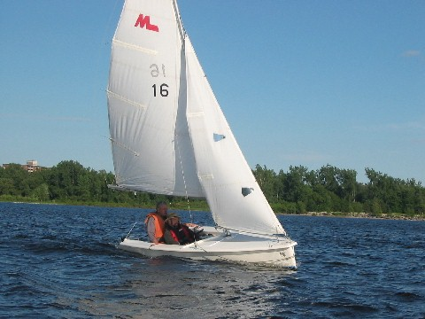

ILRC Able Sail

Welcome Sailors